LAB MANUAL
PART A
(PART A: TO BE REFERRED BY STUDENTS)
Experiment No: 9

PART B
(PART B: TO BE COMPLETED BY STUDENTS)
(Students must submit the soft copy as per the following segments within two hours of the practical. The soft copy must be uploaded on the Blackboard or emailed to the concerned lab in-charge faculty at the end of the practical in case there is no Blackboard access available.)
Roll No. C-60 | Name: Avdhut Parish Madhavi
Class SE-C | Batch: C2
Date of Experiment: | Date of Submission:
Grade:

B.1: Implement and trace the following queries. Write the SQL, execute it, and record the output for each task.
- Write a query using NOT IN to list patients who have never been diagnosed with 'Diabetes'. Test it after inserting a VISIT row whose diagnosis column is NULL, and record what changes.
SELECT patient_name
FROM PATIENT
WHERE patient_id NOT IN (
SELECT patient_id
FROM VISIT
WHERE diagnosis = 'Diabetes'
);
Output:
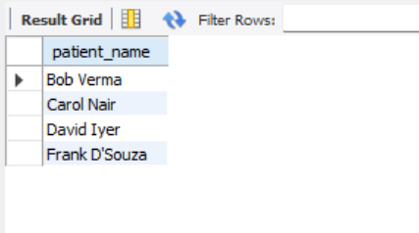
- Write a query using ALL to find the doctor(s) who have attended a number of distinct patients greater than or equal to every other doctor's count (i.e., the doctor(s) with the maximum patient count).
SELECT D.doctor_name, D.patient_count
FROM (
SELECT doctor_name,
COUNT(DISTINCT patient_id) AS patient_count
FROM VISIT
GROUP BY doctor_name
) D
WHERE D.patient_count >= ALL (
SELECT COUNT(DISTINCT patient_id)
FROM VISIT
GROUP BY doctor_name
);
Output:
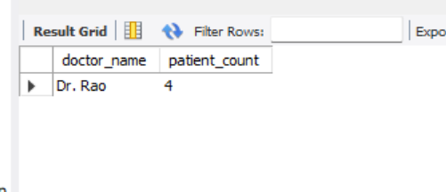

B.2: Write an observation according to the query execution.
1. The NOT IN operator is used to display patients who have never been diagnosed with Diabetes.
2. Before inserting a VISIT record with a NULL diagnosis, the query displays patients whose IDs are not present in the subquery result for Diabetes.
3. After inserting a record with a NULL diagnosis, the output remains unchanged because diagnosis = 'Diabetes' does not select rows where the diagnosis is NULL.
4. If the subquery used with NOT IN returns a NULL value, the comparison may evaluate to UNKNOWN, resulting in no rows being displayed.
5. The ALL operator is used to identify the doctor or doctors who have attended the maximum number of distinct patients.
6. In the given data, after inserting the additional visit for patient 106, Dr. Rao has attended 4 distinct patients, while Dr. Mehta and Dr. Singh have attended 3 distinct patients each. Therefore, Dr. Rao has the maximum count.

